**Lab 8: Sandbox Labs**

Paul Polsinelli

Information Technology, Arizona State University

IFT 472: Managing the Cloud

Professor Neff

Sep 20th, 2020

**Lab 8: Sandbox Labs**

**Figure 1**

*A screenshot of the DynamoDB indexes.*

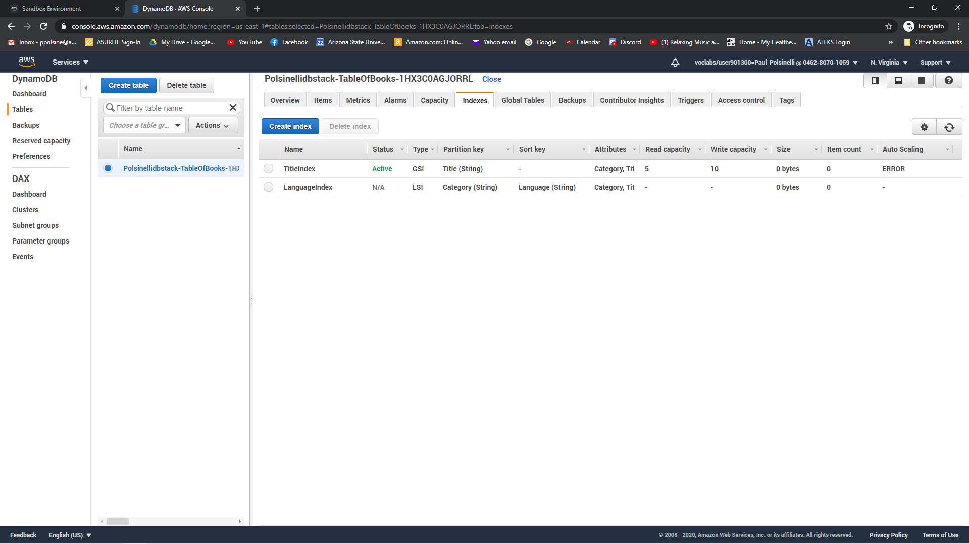

**Figure 2**

*A screenshot of the EC2 Security Groups.*

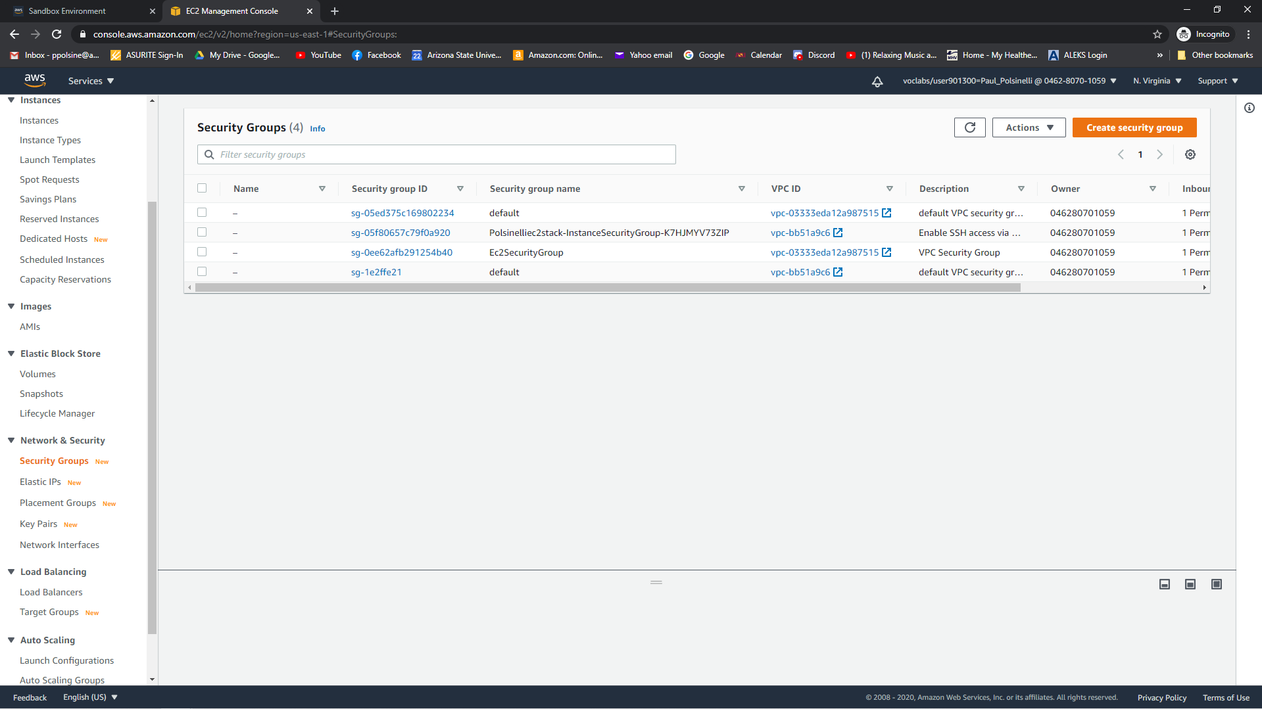

**Figure 3**

*A screenshot of the deleted stacks.*

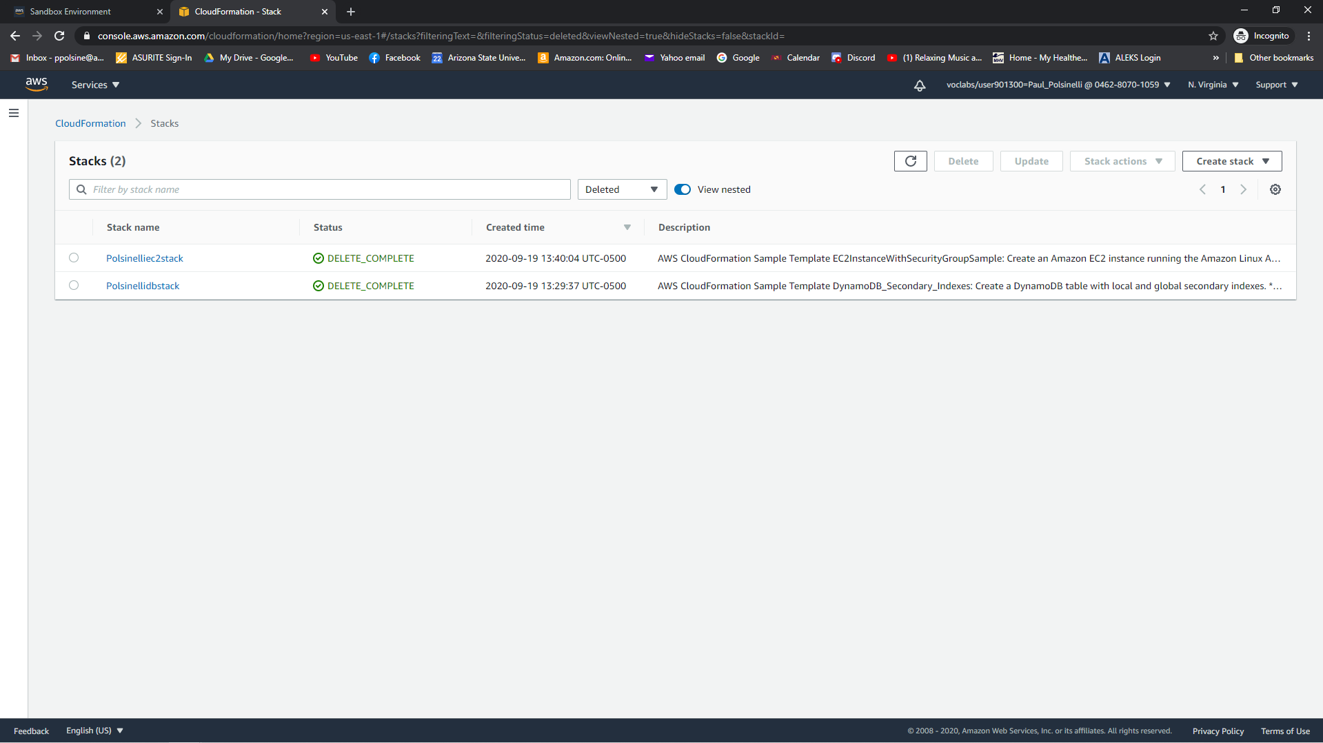

**Figure 4**

*A screenshot of the DNS zone page.*

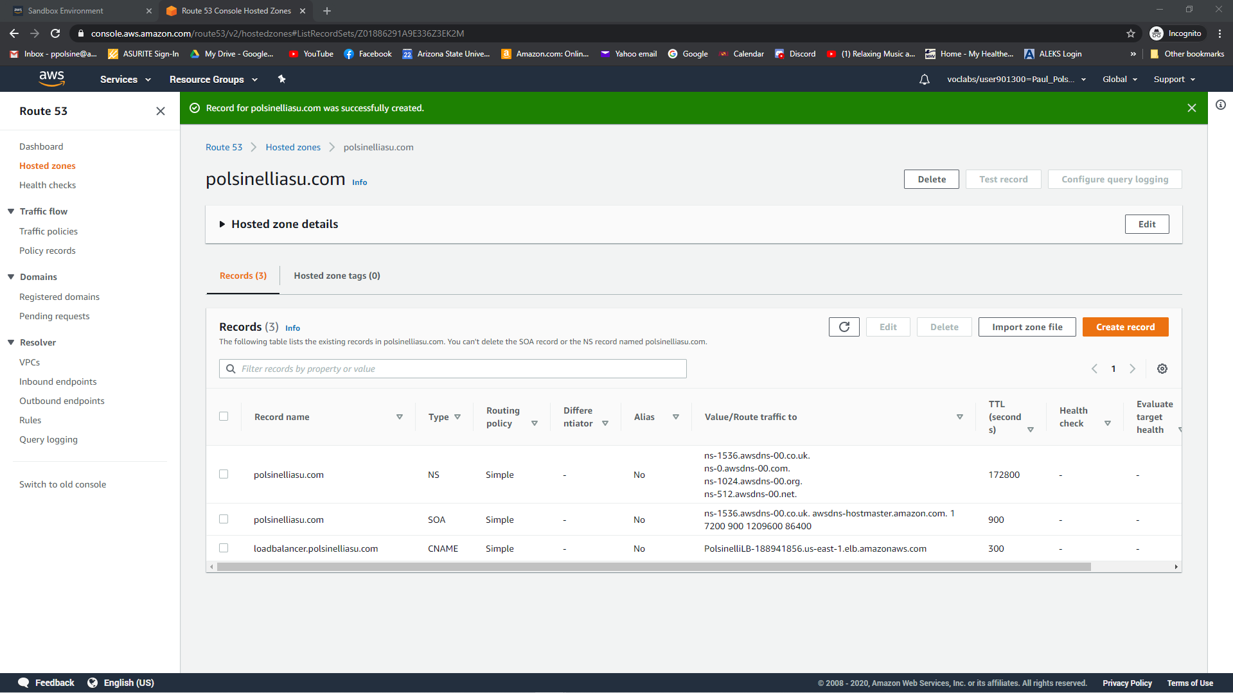

**Figure 5**

*A screenshot of the DNS zone page.*

